**Problem 1**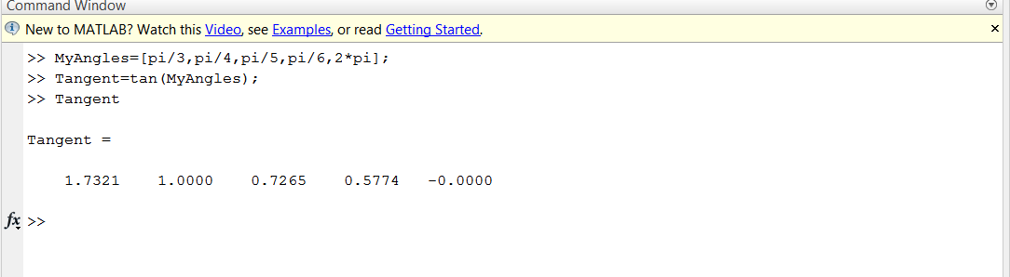

**Problem 2**

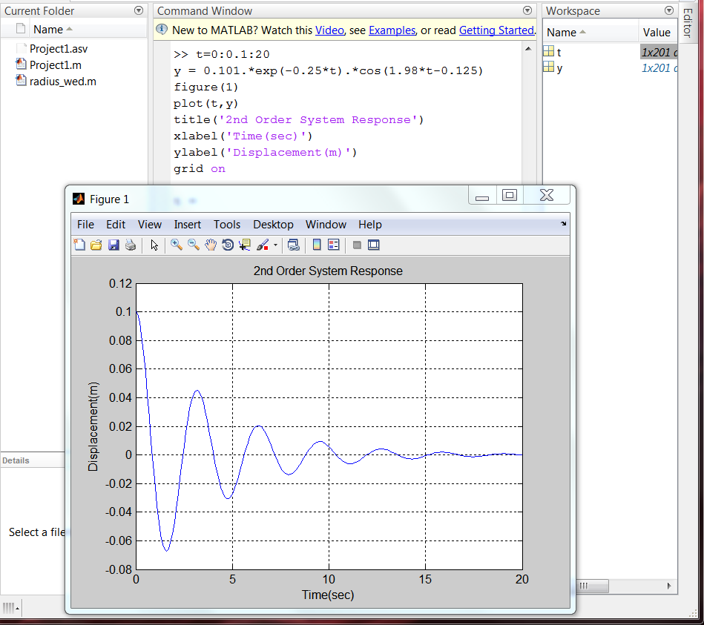

**Problem 3**

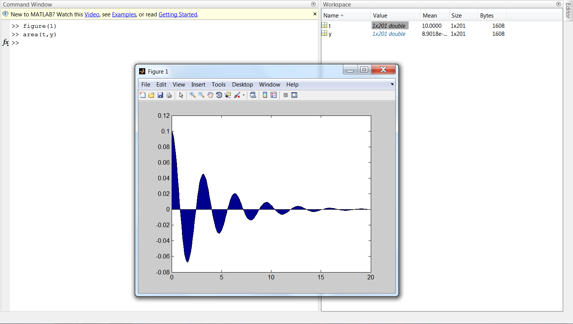

This plot was generated using the area plot function and using variables in the workspace from Problem 2.

**Problem 4**

